
National University of Modern Language
Department of Software Engineering
Lab: # 03
Presented to: Ms. Rubab Mushtaq
Presented by: Uzma Mumtaz
Due Date: 13-Oct-2026
Roll No: I-SE2254426

Subject: Opearting System

Lab # 3

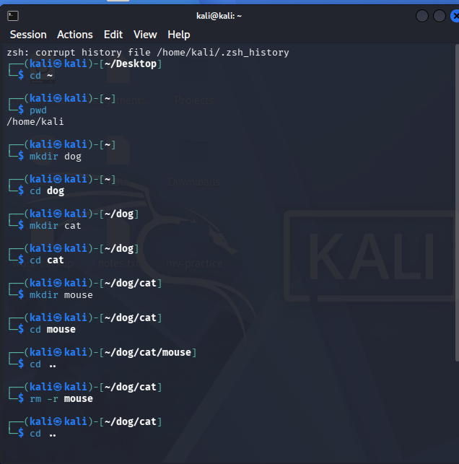

Point 3
Why rmdir is still useful when rm -r exists?
Answer
rmdir is important because it only removes empty directories.
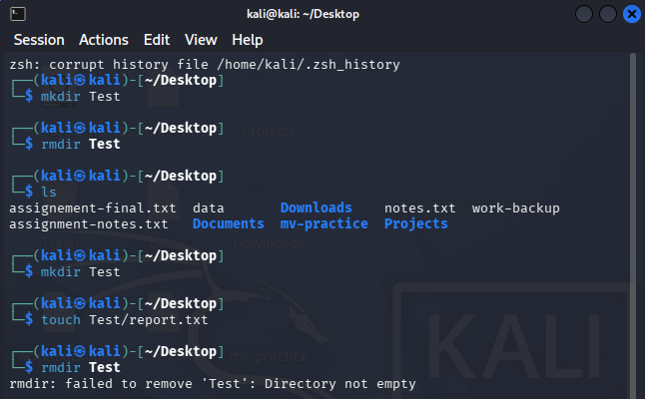
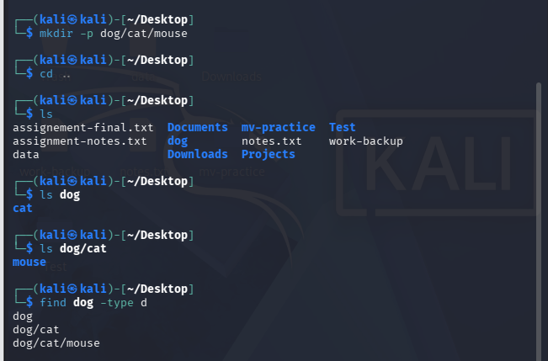
Task # 2
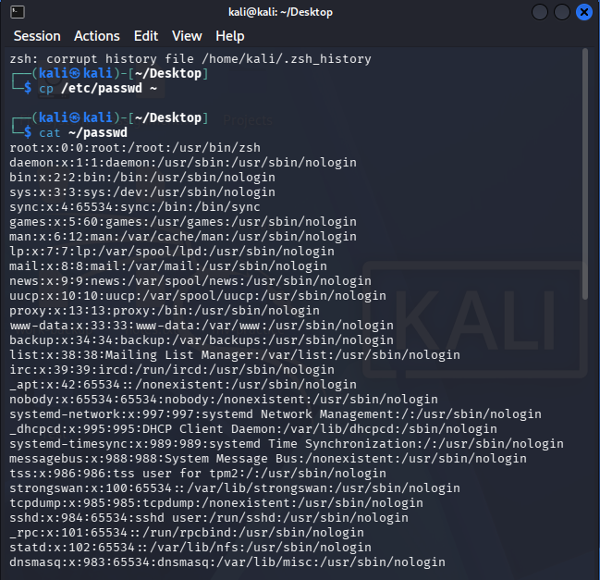
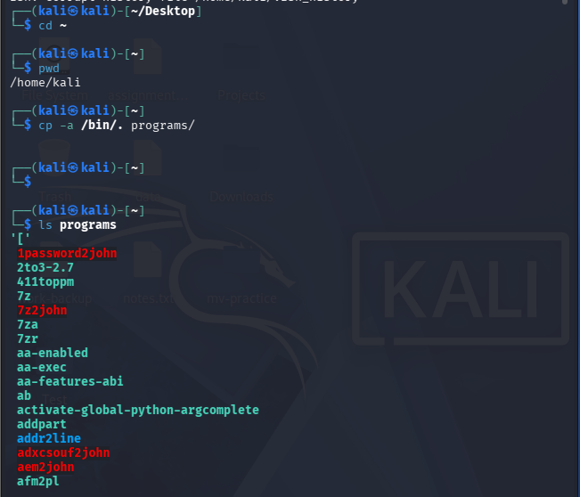
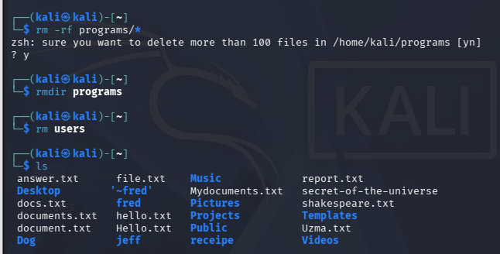
Task # 3
